Standard Operating Procedure (SOP)

Title | A7P Hydraulic Model Verification

Why | To ensure that hydraulic models of urban drainage systems are verified to a satisfactory and consistent standard.
Who | All people involved in the verification of urban drainage models.
Scope | This SOP applies to all urban drainage hydraulic models and relates to the verification with up to date flow survey data and/or historical rainfall and flooding data.

Must Have’s (H&S, Quality, Quantity, Environment, Training, Resources)
Enter the main must have’s before the requirements of this SOP are carried out e.g must have a Blue Card; Must be trained in.....
File Type | Layer Reference | Filename | Folder reference | Comments
 |  | Flow Survey Data |  | Up to date Flow Survey Data
Inputs

Outputs

File Type | Layer Reference | Filename | Folder reference | Comments
 |  | Verified Hydraulic Model
 |  | Completion of A7Work_Flow Survey |  | Completion the relevant Sections

Remember – ‘Stop, Think, Take 20’

Summary Must Do’
Enter here no more than 10 key points / requirements of this SOP
1 Complete the relevant sections of the Flow Survey Workbook  2  3  4  5 | 6  7  8  9  10

SOP
The verification process is a multi-stage process comprising DWF (dry weather) verification, storm verification and historical verification.

The verification process described in this SOP generally follows the guidance given in the CIWEM UDG “Code of Practice for the Hydraulic Modelling of Urban Drainage Systems”.

Verification will not commence until the model build audit (internal or external, as agreed with the Client Project Manager) has been completed and the model is passed. The historical verification element will be undertaken in parallel with the DWF and storm verification. Running the model with historical rainfall or synthetic design rainfall will enable gross errors to be identified and corrected as near the start of the verification process as possible.
DWF and storm verification will only be assessed at those sites and for those events where the observed data has been deemed usable. In the case of storm verification the comparison of simulated and observed flows and depths will only be undertaken for those flow monitor sites where a scattergraph plotted with the observed data is classed as “Good” or “Very Good” (examples of these are shown in the CIWEM CoP). For site where the scattergraph is classed as “Fair” may sometimes be used for comparison of depths only. Data for site with the scattergraph classed as “Poor” should not be used.
DWF verification is to be substantially completed before carrying out the Initial Verification Meeting and before commencing storm verification.

Process Map
Commence historical verification at end of model build and maintain in parallel with DWF and Storm verification.

Use historical verification to help identify modelling anomlaies and potenrial concerns e.g large predicted flooding volumes, particularly where not reported.

Complete historical verification with verified model
Historic Verification
(final)
Historic Verification (initial)
Storm Verification
Comparison of Results
Storm Verification
Storm Simulations

DWF Verification
Comparison of Results
DWF Verification
DWF Simulations

DWF Verification
No two dry days are identical, therefore DWF verification should be carried out against data for a number of recorded dry days. This applies to both short term and long term monitoring. The modeller should combine (overlay) daily DWF hydrographs and create minimum and maximum boundary envelopes, for weekdays and weekends. These boundaries may be smoothed and the model predictions compared to them. The boundary lines may be amended to account for:
- Individual days that exhibit unusual conditions caused by operational issues such as pump failure
- Seasonal effects
- Infiltration on longer time series.
Care should be taken to exclude periods of missing or inaccurate data. The shape including the timings of the peaks and troughs should fall within the boundary envelope. More guidance follows on how to undertake the DWF verification and how the maxima and minima boundary conditions can be developed and applied. Where long term data sets are available these should be compared with the simulated performance. This should be for sites where the input data and measurement data including the reading interval is of sufficient quality to be used for comparison
Weekday and weekend dry weather profiles whilst different do not capture the variations observed. This procedure uses all or a large number of dry days within the survey period. All DWF day hydrographs should be combined to create maximum and minimum boundary hydrographs, so creating a window of acceptability. This should be completed for weekday and weekend. Dry days can be defined as a day of zero rainfall that follows a day of less than 1mm of rain. Dry weather verification should be considered ‘good’ if the predicted hydrograph lies between the maximum and minimum boundaries.
In some instances where the flow survey data is over a long period and there has been a significant change in baseflow infiltration it may be necessary to remove the baseflow element prior to plotting the DWF day hydrographs.
The flow survey data needs to be imported into an Excel spreadsheet and graphed as shown in Figure 1. At each time-step, the plotted maximum (in red) and minimum (in blue) values create boundary hydrographs. However, without smoothing these boundaries are very jagged. Accordingly, a smoothing process needs to be applied.

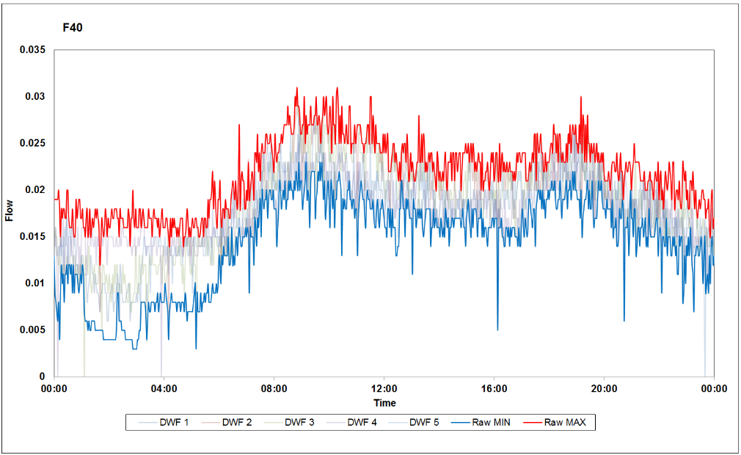
Figure 1: Raw Imported Data (before smoothing)
A more advanced approach involves smoothing the lines to give more defined boundaries. This helps spiky hydrographs or those which are heavily influenced by upstream or downstream pumping stations as the pump cycles tend to be dampened out. An example of a smoothing method for this is the Savitzky-Golay filter which is shown below.
$$Y_{j}=\sum_{i=1\left(m-1\right)÷2}^{i=\left(m-1\right)÷2}{C_{i}y_{i+1}}$$
$$\frac{m+1}{2}≤j≤n-\frac{m-1}{2}$$
Where: x is an independent variable,
y_{j} is an observed variable and
m and C_{i} relate to “convolution coefficients.
The Savitzky-Golay filter works in a similar way to a moving average, but uses ‘convolution coefficients’ and low-degree polynomials. It retains the exact peak and trough times and does not distort the shape of the data. For the values to be generated it uses data from outside of the 24-hour period of the individual dry day. At maximum, 42 minutes of data (at 2-minute intervals) from each of the two adjoining days need to be used.
Figure 2 shows the Savitzky-Golay filter in use. The base data is the same as for Figure 1, but the Savitzky-Golay filter smoothes the underlying five DWF days used with the minimum and maximum lines taken from these smoothed lines. Individual dry days which exhibit unusual characteristics (e.g. high depth and low flows due to pump failure downstream) should not be used and removed.
When using long time-series or extended data, only dry days should be used where the recession from preceding storms has fully receded. This for example may be 36 to 48 hours after rainfall has ceased.

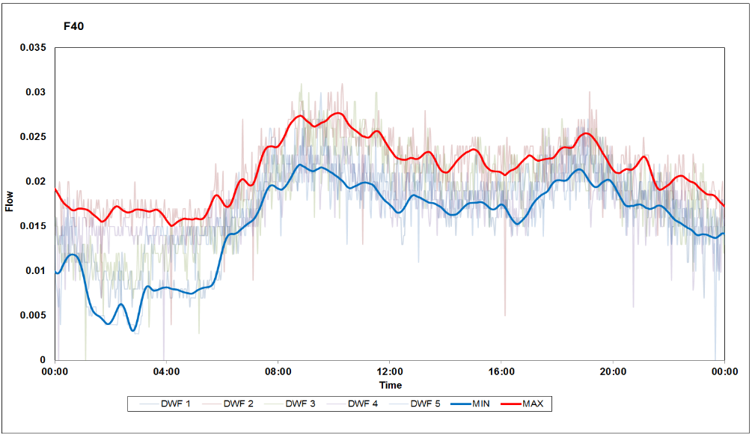
Figure 2 - Smoothed Maximum and Minimum Boundary Hydrographs using Savitzky-Golay Filtering

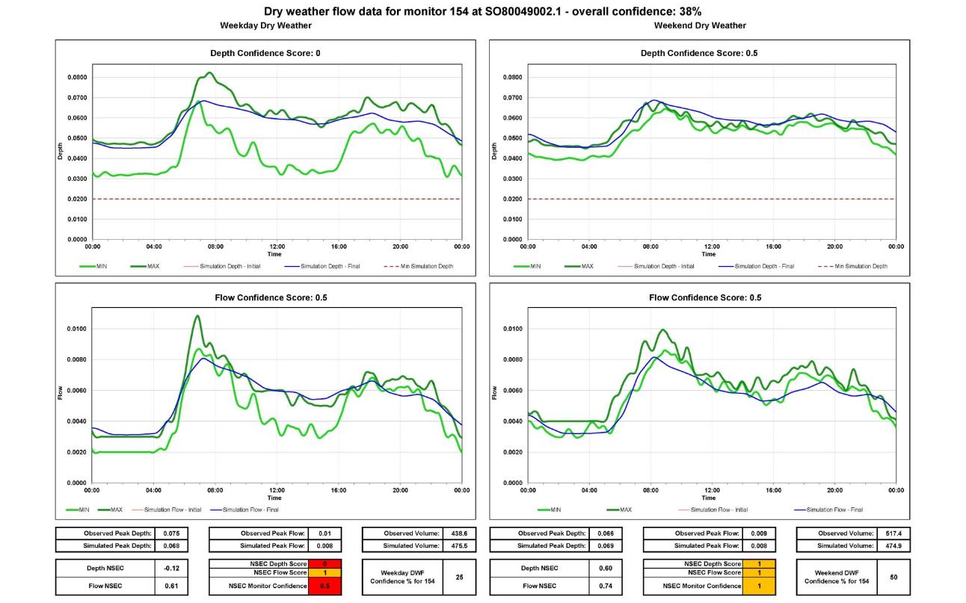
Figure 3 - Example of Dry Weather Verification Plots with NSEC and Confidence scores

An acceptable dry weather verification is achieved if the simulated flow and the simulated depth lies largely inbetween the smoothed maximum and minimum lines. There can be exceptions to this when there are significant, intermittent trade discharges upstream of the flow monitor site.

Storm Verification
With the exception of the removal of gross modelling errors, storm verification shall be commenced only once the Initial Verification Meeting has taken place.

Verification will only be assessed at those sites and events for which the observed data has been deemed usable.

Storm flow verification is only to be commenced after dry weather flow verification has been substantially completed and signed-off and after the historical verification has been investigated and understood.

Storm Verification is to be carried out for three storm events per monitor location unless agreed otherwise.

The next step is to make a detailed numerical comparison of the results against the specification tolerances for peak depth, peak discharge and volume.

After completing a set of storm flow verification simulations produce comparative plots of simulated and observed data. Inspect comparative depth/discharge/velocity plots for each event site by site and make notes in a tabular form as shown in the example below. Note differences in time to peak, significant shape differences, base flow anomalies etc (ref CIWEM UDG Code of Practice for the Hydraulic Modelling of Sewer Systems (UDG CoP).

Flow Monitor | Storm Event A | Storm Event B | Storm Event C
M01
M02
Etc…

Any significant problems revealed during the above inspection are to be resolved and the cycle repeated until all obvious errors have been dealt with. Correction of specific modelling issues shall be in accordance with the relevant procedures.

Details of all changes to the model shall be recorded.

Non-compliance is acceptable provided that it is justified by unavoidable limitations in data or the modelling software. Consideration must be given to operational issues.

Verification must be based on genuine data collected from site or other reliable sources. Arbitrary changes to model parameters and connectivity must not be made.

2.2 Detailed numerical comparison of the results

The next stage is to make a detailed numerical comparison of the results against the specification tolerances for peak depth, peak discharge and volume. The target tolerances at flow monitors are as follows;
Parameter | General | Critical Locations | Comments
Shape | Good match  (NSEC if used >0.5) | Good match  (NSEC if used >0.5) | An evaluation technique may be used to compare the shape such as the Nash-Sutcliffe Efficiency Co-efficient (NSEC) method together with a visual check.
Time of peaks and troughs | ±0.5 hour | ±0.5 hour | The timing of the peaks and troughs should be similar having regard to the duration of the event
Peal depth (un-surcharged) | ±0.1m or ±10% whichever is greater | ±0.1m
Peak depth (surcharged) | +0.5m to – 0.1m | ±0.1m | Relaxation may be appropriate in deep sewers. Where coupled 1D-2D models are used the ‘critical locations’ criteria should apply
Peak flow | + 25% to -15% | ±10%
Flow volume | +20% to -10% | ±10% | Excluding poor / missing data

In relation to these tolerances ‘critical locations’ are where small differences in water level could affect the performance of the sewer system (e.g. at CSO’s, bifurcations, flooding locations etc) or where coupled 1D-2D modelling is undertaken.

Produce a matrix of monitor/event/parameter as shown below.

For depth
• Within specification = “ok” = green. Score 3.
• Close to specification (within 0.1m of target tolerances) = “fair” = yellow. Score 2.
• Well beyond specification = “no” = red. Score 0.
• No data or unreliable data = “n/a” = white. Score 0.
For peak flow
• Within specification = “ok” = green. Score 3.
• Close to specification (within 5% of target tolerances) = “fair” = yellow. Score 2.
• Well beyond specification = “no” = red. Score 0.
• No data or unreliable data = “n/a” = white. Score 0.
For volume
• Within specification = “ok” = green. Score 3.
• Close to specification (within 5% of target tolerances) = “fair” = yellow. Score 2.
• Well beyond specification = “no” = red. Score 0.
• No data or unreliable data = “n/a” = white. Score 0.

For each parameter;
• a total score of 8 or more (3 “ok” or 2”ok” + 1”fair”) is verified.
• a total score of 6 or 7 (2”ok”, or 1”ok” and 2”fair”, or 3”fair”) is marginal
• a total score of 5 or less is not verified

Any divergence from fully verified at all sites with reliable data is to be fully investigated and highlighted in the verification section of the SMS Report . The following output shall be provided for each flow monitor as shown below, in the verification workbook.

NB: Where the calculated numerical assessment does not accurately reflect the quality of the verification for a particular flow monitor (e.g. where poor velocity data causes the volume comparison to be poor, yet the overall shape of the flow hydrograph is good, or alternatively where spurious data spikes lead to a close comparison of peak flows, yet the shape of the hydrograph is poor) then the overall assessment shall be manually overridden by the modeler.

The results of the verification shall be discussed at the Final Verification Meeting, where the level of verification is agreed, and the scope of any model limitations and implications these may have on the Risk Assessment Stage. The factors influencing the set up of the Risk Assessment models are also considered at the Final Verification Meeting.

Figure 4 shows an example of a “good” Storm Verification.

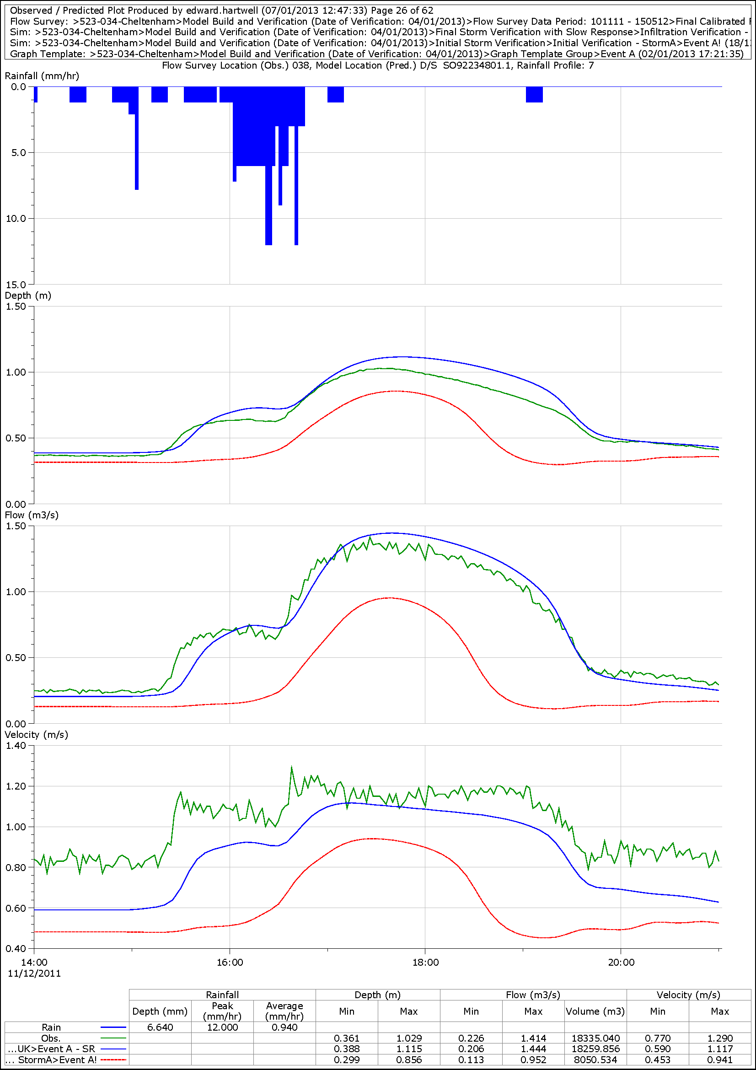

Figure 4 - Example of “Good” Storm Verification

Historical Verification
Historical verification is an important exercise for two key reasons. Firstly, it confirms the model confidence in terms of predicting known historical occurrences such as flooding or combined sewer overflow (CSO) spills. Secondly, it is important to assist the modeller in identifying potential modelling anomalies that may lead to erroneous predictions (for example, an erroneously small pipe size leading to excessive flooding).

Verification against historic event data as a minimum should be undertaken initially during the early stages of verification as this can often provide a useful sensibility check as to the performance of the model. Ideally, historical verification should be treated as an ongoing process from the end of model build, through stability checking, initial verification and verification against flow survey data.

Historical verification shall be completed following the completion of the verification against flow survey data under dry weather flow conditions and before verification under storm conditions.

It is important sufficient focus is given to historical verification through the whole of the modelling exercise. The historical verification exercise is used to judge a model confidence and it is important that the model can be demonstrated to reflect historical performance, and the associated reporting explain the limitations and risks where historical verification has not been fully achieved.

Should any anomalies or confidence issues be identified within the historical verification exercise, then the model will be updated. This may require site investigations or further data collection and will require consultation with the Client Project Manager (PM).

The comparison of predicted and actual flooding requires use of both historical and design rainfall events.

Historical events may be derived from observed rainfall records, STORMPAC data or other appropriate time series, localised to suit the catchment under consideration. Historic events should be obtained for specific historical incidents such as flooding or CSO spills. There is increasing amounts of high resolution historical data, particularly for flooding events post 2005. Attempts should always be made to obtain this for the catchment under considerations.

Design events shall be 1, 2, 5, 10, 20, 30, 40, 50 and 100 years return period and 15, 30, 60, 90, 120, 240 and 480 minute duration with a summer profile. Longer durations may be needed for models of large catchments. Larger return period design events may be appropriate for some integrated LLFA or Local Authority (LA) partnership studies.

The user must confirm that the rainfall data used has antecedent condition parameters that are appropriate to the runoff model being used. Full details of the set up of antecedent conditions for historical verification and design purposes is given in A7P_Antecedent Conditions.

The verified model should be simulated with the identified historical rainfall data, design events or time series rainfall (where each is available).

The predictions of flooding shall be compared with the reported data. The model should reproduce all reported flooding in terms of location, severity and frequency where records exist. The model should not predict flooding where no record exists of flooding having occurred. Where a lack of comparability is evident further investigation, site survey or model upgrade will be required, through consultation with the Client PM. Possible causes are;

- Model not representative of reality.
- Recorded flooding due to cause other than hydraulic overload of sewer system (e.g. blockage, flooding from highway drainage etc).
- Flooding occurs but has not been reported (for example, may flow into a watercourse, ditch or adjacent surface water (SW) gully, and not be noticed by the public).

All predicted flooding shall be investigated and reported. Where appropriate the model will be adjusted in line with the investigations carried out as part of the historical verification exercise and reported. A statement of verification against historic data, highlighting areas where confidence is reduced by a lack of fit or failure to represent historical observations, should be included in the SMS Report, the verification workbook and the MICAS workbook. This reporting should consider not only reported locations which are predicted by the model but also both un-modelled historical events and modelled only (and not confirmed historically) predictions.

Given the circumstantial nature of much historic data however, some flexibility in interpreting results is permissible. Severe surcharge (close to cover level) may be taken as evidence to support flooding predictions for which no records exist.

Site visits and manhole inspections may be undertaken, though the extent of these will be agreed with the Client PM at the verification meetings. Alternatively, some flood risk assessments may be undertaken to establish the impact of flooding from a manhole (i.e. the number and type of properties affected) or whether the flooding may drain away and not be reported. The number and extent of any flood risk assessments will be agreed with the Client PM at the verification or risk assessment stage.

The predictions of CSO and storm tank spills shall be compared with reported data. The model shall reproduce spill frequency and volume where recorded data is available. Where historic data is more subjective, the predicted operation shall be generally similar to perceived performance. Where significant discrepancy is evident further investigation will be required to establish the reason, which may be model errors or errors in historic data.

Modellers should be mindful of the need to undertake historical verification and ensure that during any site surveys notes and comments are recorded relating to extent of surcharge, ragging on step irons, CSO discharges or ragging at outfalls, ideally with photographic evidence.

Telemetry data indicating failures or high level alarms at major ancillaries should be sought from the Plant Monitoring and Control System - PMCS. Where failures are storm related then this data should be used as part of the historical verification.

When undertaking 2D modelling, a more detailed form of historical verification is undertaken as part of the model validation exercise, which involves confirming the extent of flooding against more detailed records.

